**EE 414 Lab 6 Report:**

**Band Pass Filter**

**Due: November 17, 2021**

**By: Julio Torres, Johnathan Leisinger, and Prince Tshombe**

**Introduction**

**For the 6th lab of the class, it was two weeks. We were told that we need to design a band pass filter.**

**Part 1: Ideal Lumped Element Filters**

**Ideal Filter Calculations**

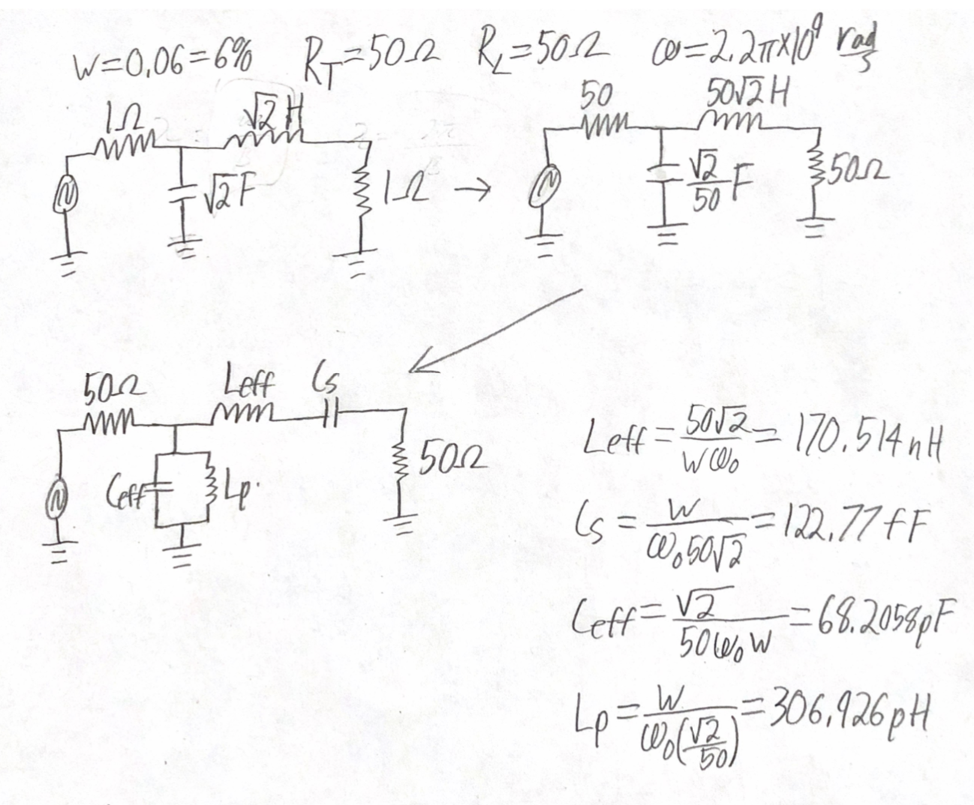

**Schematic of the Ideal Bandpass Filter**

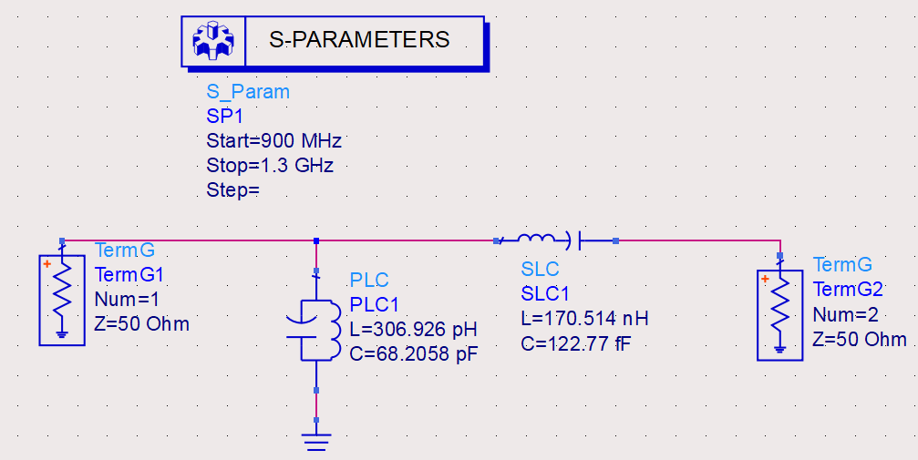

**S21, S11, and S22 of the ideal filter:**

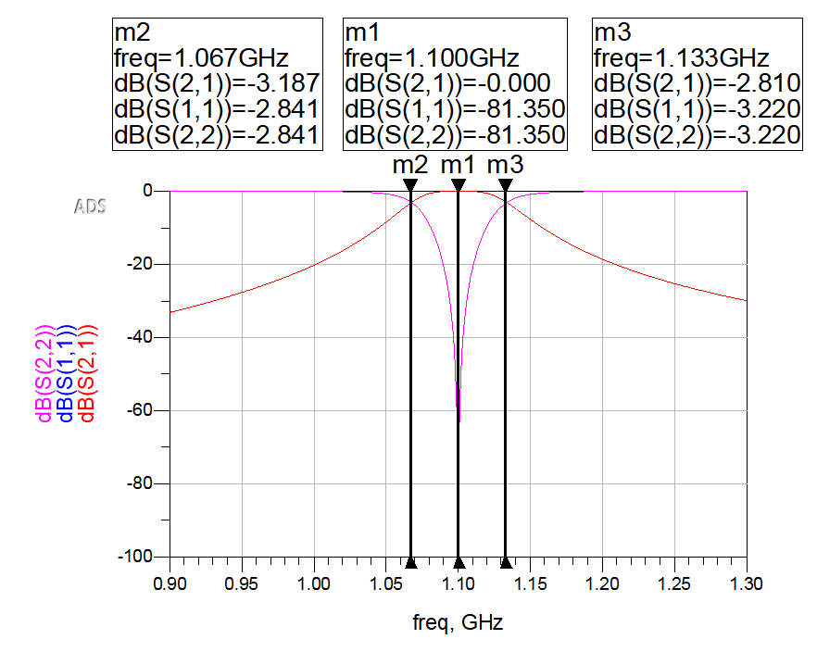

**Part 2: Ideal Lumped Element Filters**

**Derivation of Ceff**

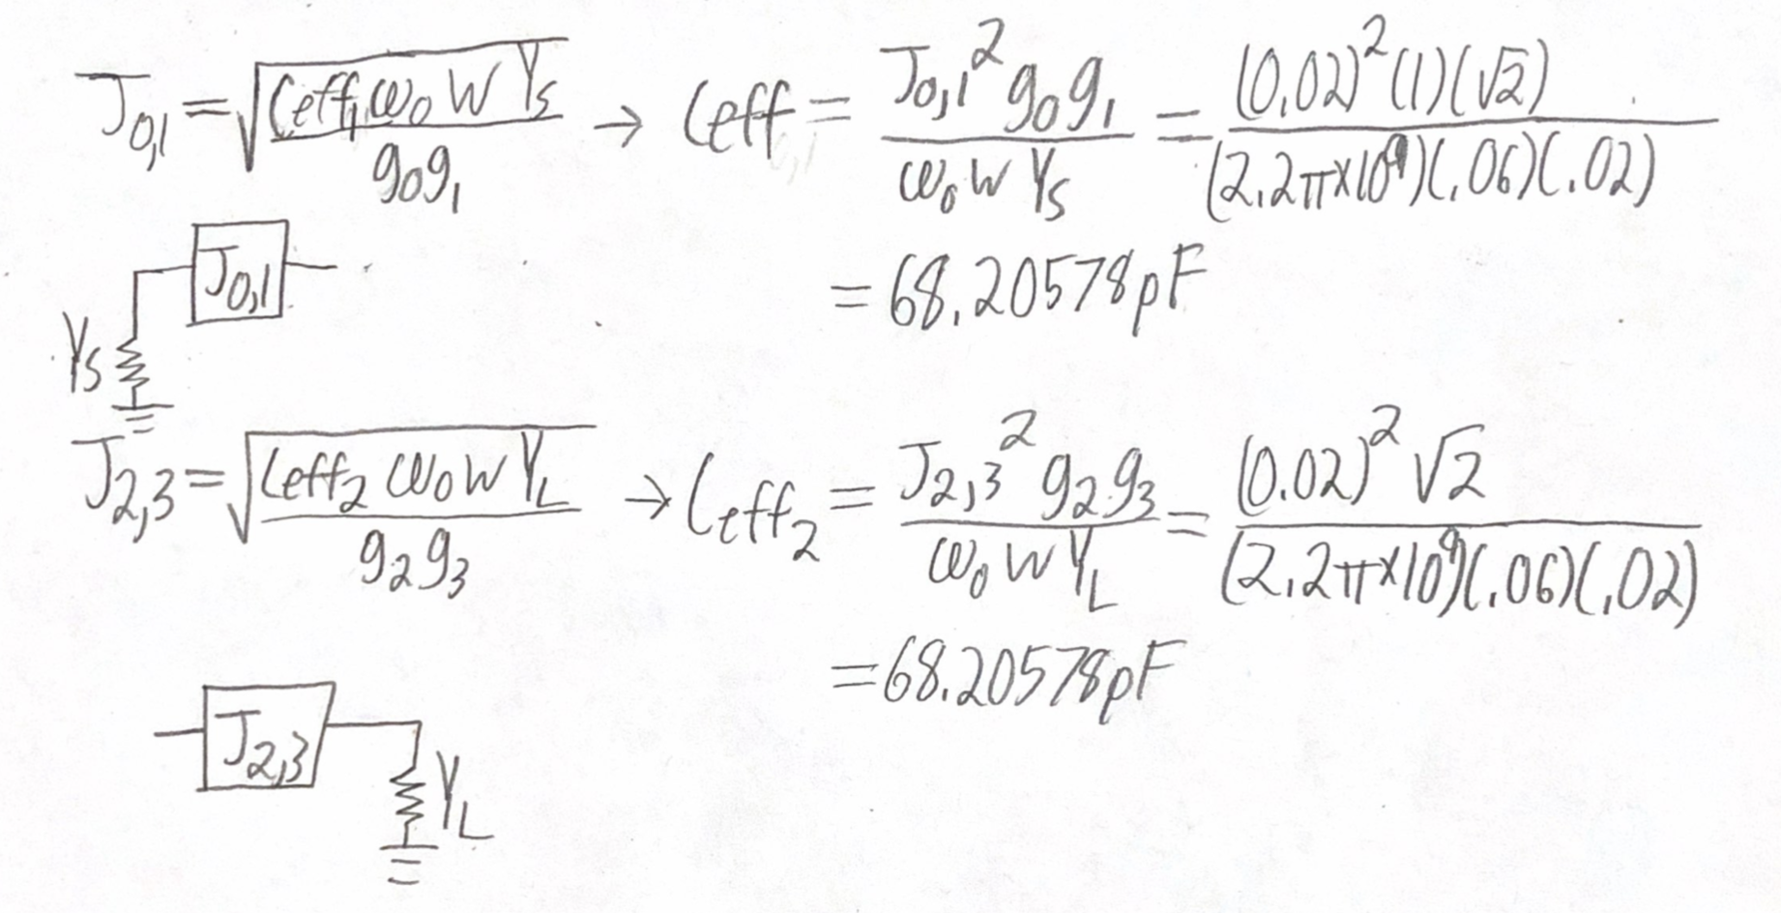

**J-inverted Design and Derivations**

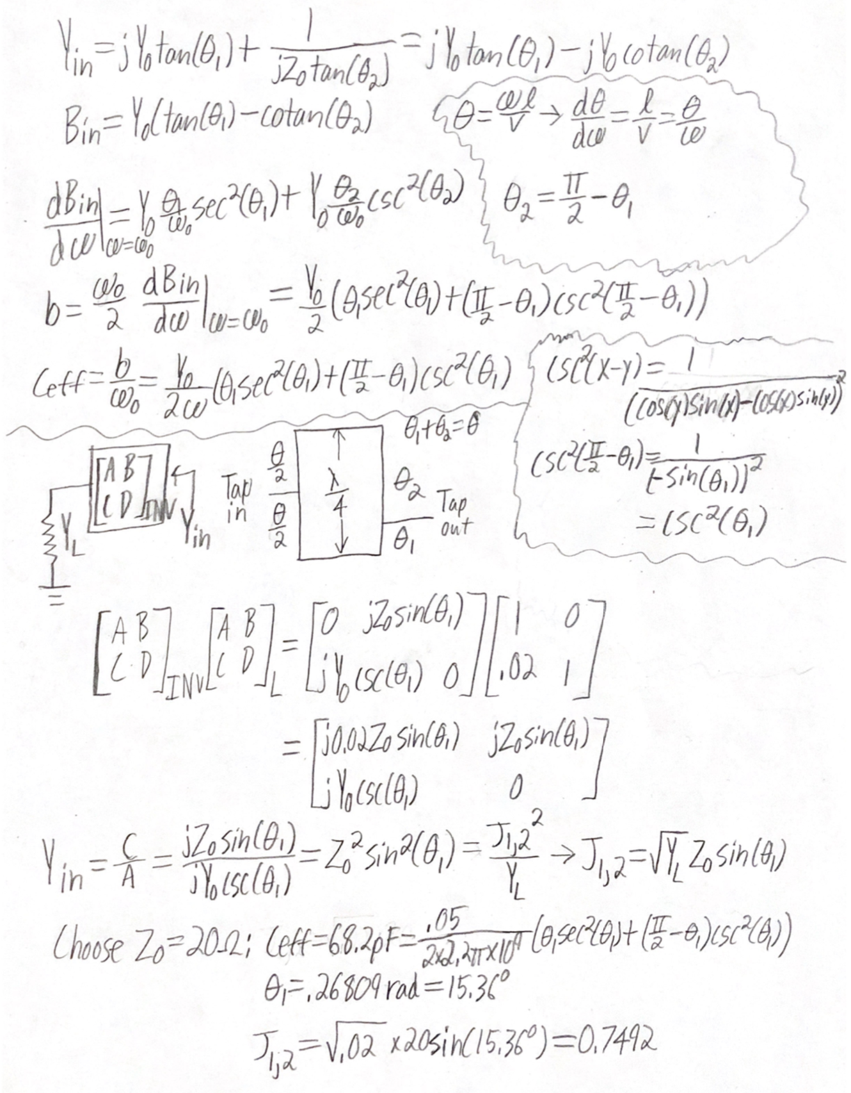

**Part 3: Filter Implementation**

**Schematic of the transmission implementation:**

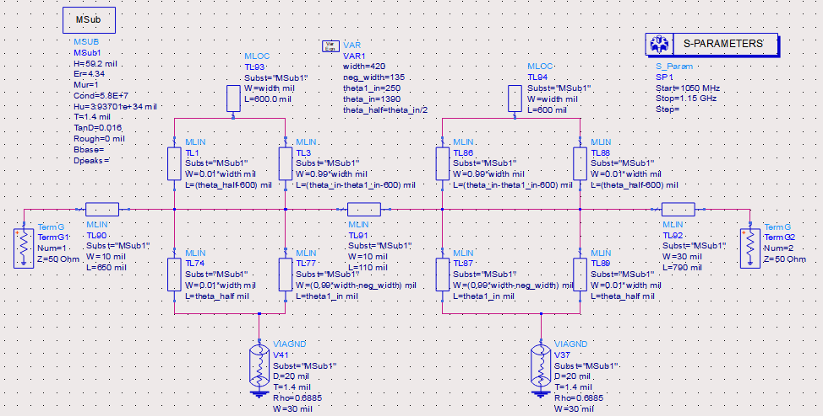

**LineCalc Calculations:**

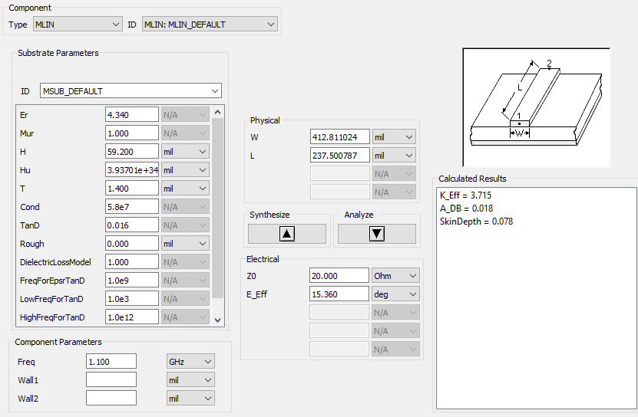

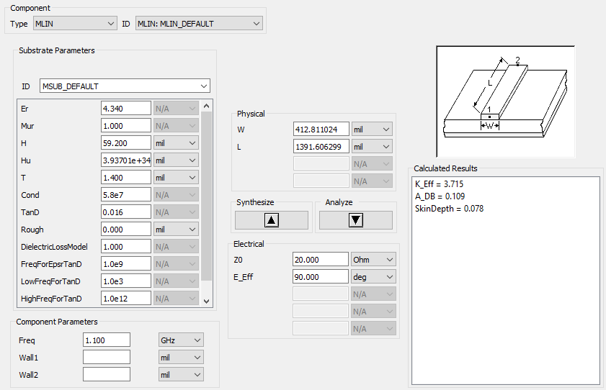

**S-parameter simulation:**

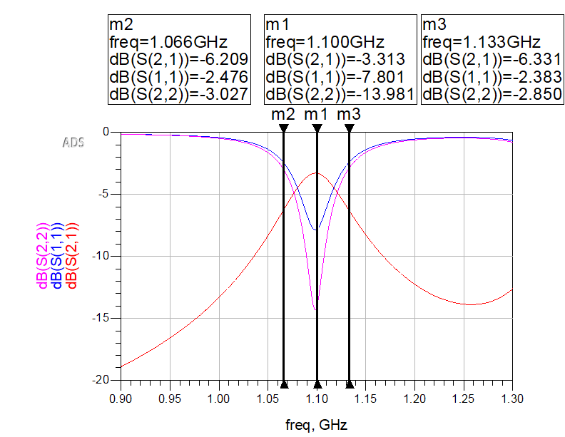

**Vs Ideal S-Parameter Simulation:**

